To preview the changes for the new Fannie Mae Uniform Residential Loan Application (Form 1003), you will select the following on the Lender Setup screen. This is also available in the lender setup screen itself to populate future loans.

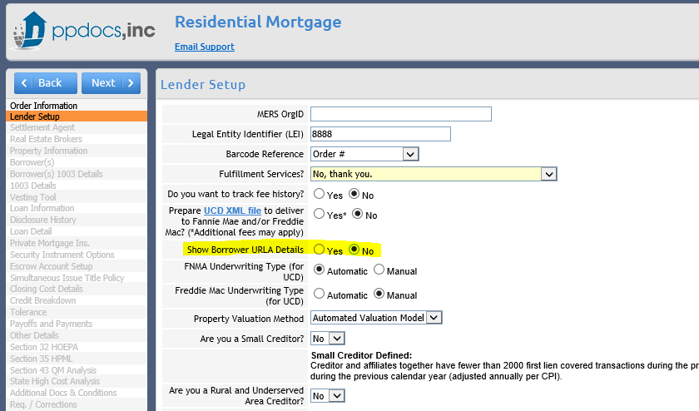

Selecting YES will give you another question to preview the 2021 BETA version. Click YES.

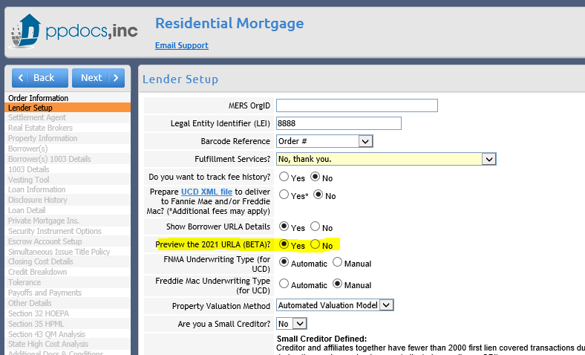

This will give you additional fields on the Borrower(s) 1003 details screen. The existing information popups regarding assets, liabilities, etc have already been updated with the new fields necessary to complete the new 1003. Old fields will still be there as well until the document is retired.

There is also a generic 1003 addendum for each borrower as a free-form field for you to enter anything that needs to be on the addendum that is not elsewhere referenced.
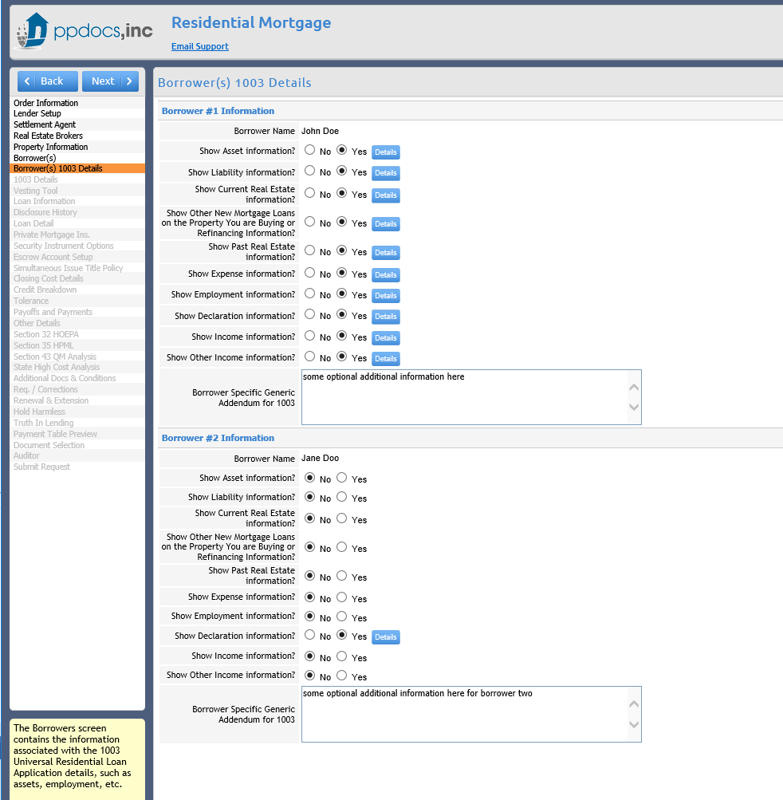

There will also be an entirely new screen of miscellaneous fields required for the new 1003 to populate that are in one location for ease of access. This screen will only show if you are previewing the new 2021 BETA version of the 1003.

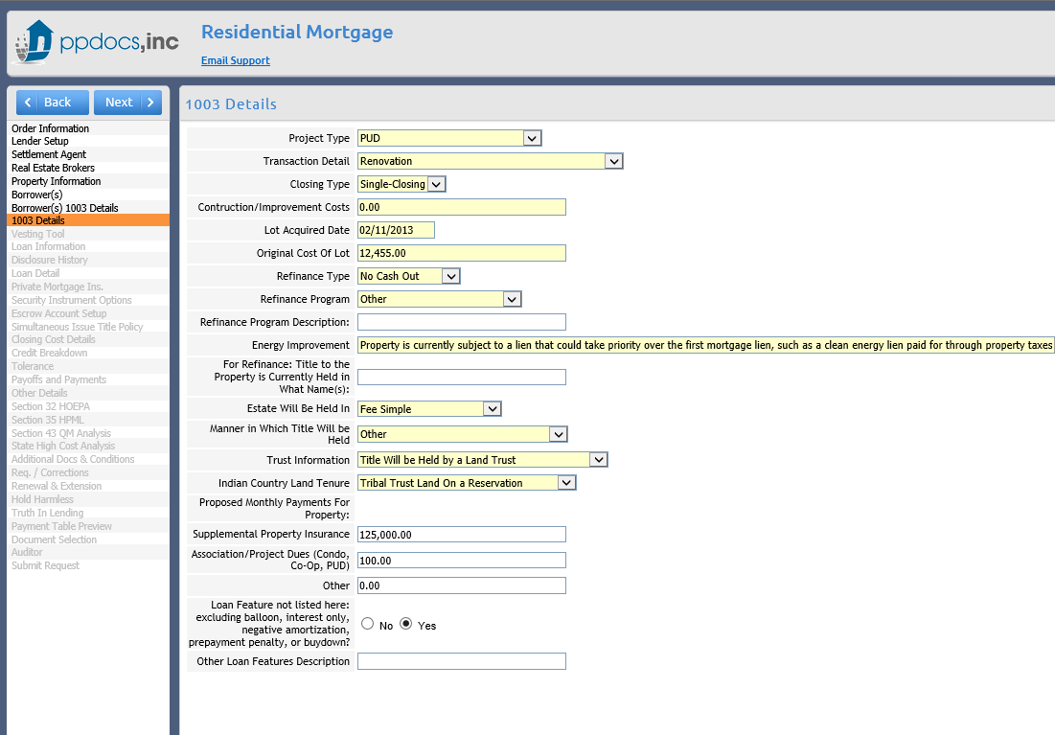

Information regarding the new 1003 is also scattered around the order form. Information about the actual collection of the application is on the loan information screen.

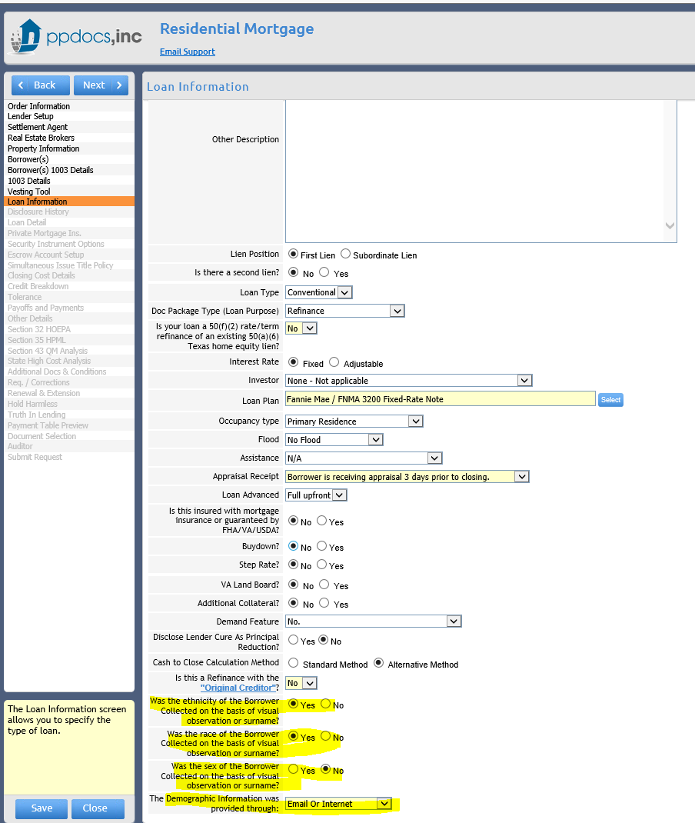

To filter in the document, you will need to select it from the additional documents screen.

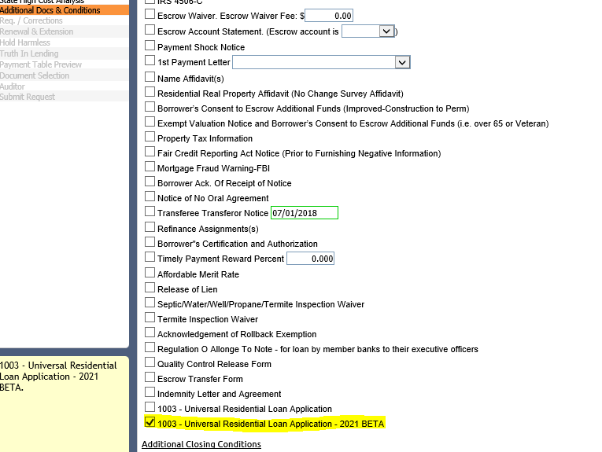

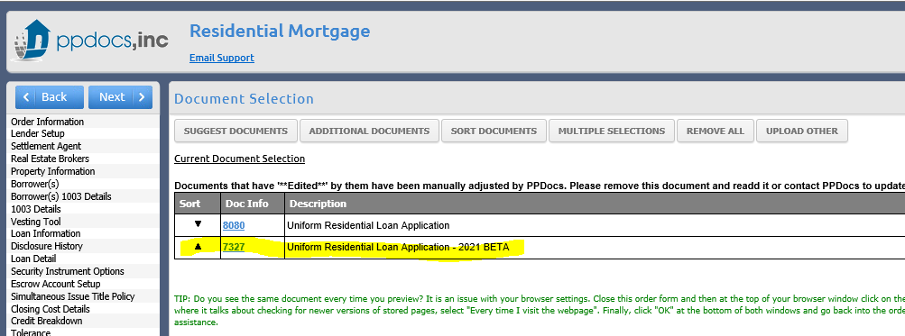

Addendums will automatically pull into the document. For example, indicating that a borrower is unmarried will not only prompt for more information, but will automatically include the addendum in the document.
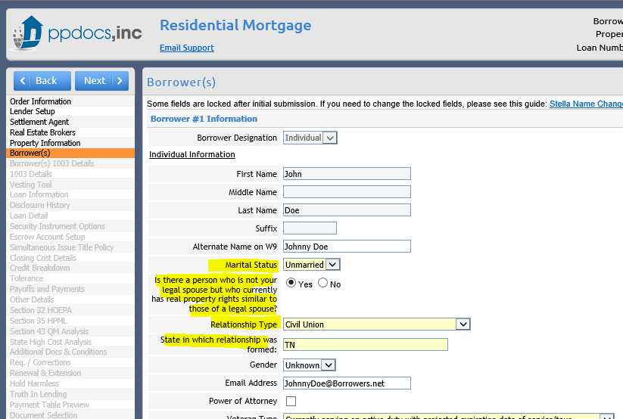
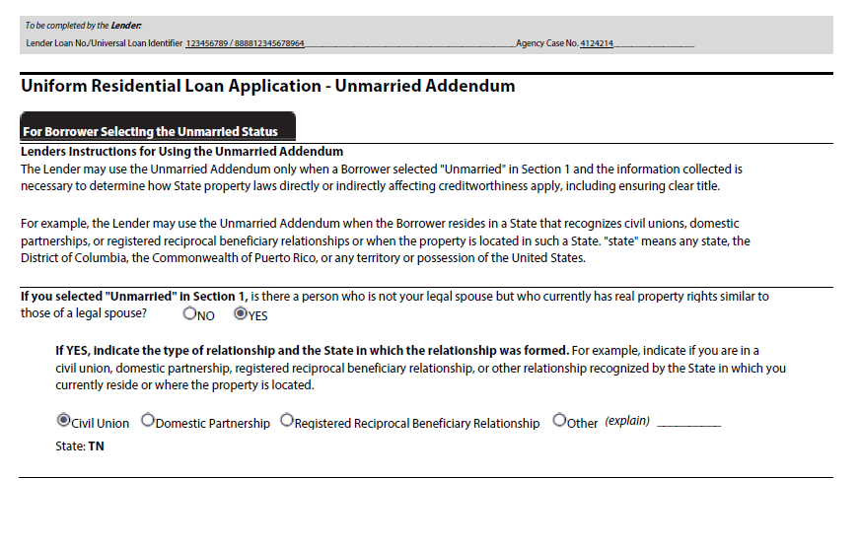

Lender Loan Information will also automatically be included.
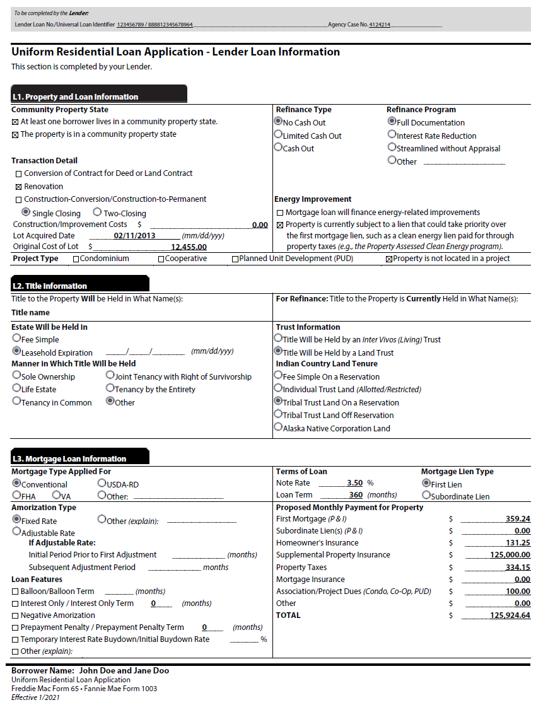

The continuation sheet will automatically populate with items that did not fit in the appropriate boxes in other parts of the 1003, such as extra income from other sources, assets, etc. Borrower 1’s 1003 contains all parties’ assets, liabilities, etc if they have indicated that that they are doing joint credit. The additional information for borrower one does the same.

